Site Environmental Management Plan (SEMP)

Thredbo Alpine Hotel External Maintenance Works

Thredbo Alpine Resort
Kosciuszko National Park NSW

July 2022

Thredbo Alpine Hotel External Maintenance Works
Site Environmental Management Plan (SEMP)

Kosciuszko Thredbo Pty Ltd
1 Friday Drive
Thredbo New South Wales 2625
www.thredbo.com.au

Document Control
Revision | Date | Revision Type | Author | Approved by
A | 28.06.2022 | Draft | C.Chalk | A.Harrigan
0 | 21.07.2022 | Final | C.Chalk

Contents

1 Introduction 1
1.1 Purpose of SEMP 1
1.2 Environmental and Social Sustainability Policy 1

2 Project Details 1
2.1 Project Location 1
2.2 Project Description 1
2.3 Construction Details and Activities 1

3 Environmental Management 2
3.1 Key Contacts and Roles 2
3.2 Communication 3
3.3 Environmental Incident and Emergency Response 3
3.4 Risk Assessment 4
3.5 Mitigation and Management Measures 5
3.5.1 General 5
3.5.2 Soil and Water Quality 5
3.5.3 Flora and Fauna 5
3.5.4 Waste and Hazardous Substances 6
3.5.5 Noise and Vibration 7
3.5.6 Air Quality 7
3.5.7 Traffic and Transport 7
3.5.8 Cultural Heritage 8

4 Monitoring 8
4.1 Environmental Incidents Reporting 8
4.2 Complaints Reporting 9

5 Appendices 10

Appendix A Site Plans 10

Appendix B Risk Matrix 14

Appendix C Environmental Schedules 15

Tables
Table 1: Construction Detail and Activities 1
Table 2: Key Contacts 2
Table 3: Summary of Consultation Activities 3
Table 4: Risk Assessment 4
Table 5: Soil and Water Quality Management 5
Table 6: Flora and Fauna Management 5
Table 7: Waste and Hazardous Substances Management 6
Table 8: Noise and Vibration Management 7
Table 9: Air Quality Management 7
Table 10: Traffic and Transport Management 7
Table 11: Cultural Heritage Management 8

Introduction
This Site Environmental Management Plan (SEMP) has been prepared for implementation by Kosciuszko Thredbo Pty Ltd (KT) (and its contractors) for the Thredbo Alpine Hotel (TAH) external maintenance works (the Project).

Purpose of SEMP
This SEMP has been developed to outline how construction processes for the Project are to be managed in order to maintain and protect the environmental values of the Project site and surrounds.

Environmental and Social Sustainability Policy
All activities undertaken by KT will be in accordance with the organisations Environmental and Social
Sustainability Policy 2021.

Project Details

Project Location
The TAH is located at 17 Friday Drive, Thredbo Village 2625, on land formally described as Lot 861/DP1128686. The site is centrally located in the Village, situated slightly above and to the south of Friday Drive and Thredbo River.

Project Description
The Project will comprise the removal of existing native hardwood cladding and replacement with a like-for-like timber product.

Construction Details and Activities
A summary of the construction program and activities is provided in Table 1.
Table 1: Construction Detail and Activities
Aspect | Details
Site Access | The Project site is accessible via Friday Drive and Mowamba Place.
Disturbance footprint | No ground disturbance is proposed.
Construction Program and Activities | Pre-construction activities involve site preparation works, which will include:  - establishment of site boundary/fencing and no-go zones;  - establishment of site compound; and  - erection of site signage and pedestrian/traffic controls.  The proposed construction program will comprise the following:  - mobilisation of plant and machinery;  - erection of scaffolding;  - removal of existing cladding, including segregation of materials to be recycled and materials to be disposed of off-site;  - installation of new cladding;  - painting new cladding; and  - replacement of windows, trims and facia, where required (i.e. broken / damaged windows).  Post-construction activities will comprise:  - demobilisation of plant and machinery; and  - site clean-up.
Machinery, Plant and Equipment | Construction vehicles and plant will include (but is not limited to):  - delivery trucks; and  - mobile crane.
Stockpiles / Material Storage | Materials (e.g. old and new cladding) will be temporarily stockpiled in various locations depending on the area of works at the time. Temporary stockpile locations will likely include the Hotel carpark, Alpine Bar and carpark below Keller Concourse.  Larger stockpiles will be located within Thredbo’s tip carpark. Access to these locations will be restricted to KT staff and contractors.
Site Facilities and Compound | There will be no compound or temporary structures within the construction corridor. A portion of the carpark below the Keller Concourse will likely be used for the temporary storage of materials and construction vehicle parking.  Existing amenities (e.g. staff room and toilets) at Valley Terminal and the TAH will be available for construction staff.
Project Timing | The anticipated timing for commencement of works is between October 2022 – May 2023. The maintenance works will be carried out intermittently during the months of October - May over a five-year period between 2022-2027.

Environmental Management

Key Contacts and Roles
Key contacts for the Project are provided in Table 2. Prior to commencement of works, contact details will be updated for Project personnel.
Table 2: Key Contacts
Contact | Role | Contact
Key Project Personnel
TBC | Project Manager | -
Brent Bourke (KT) | Environmental Officer | -
TBC | Construction Contractor | -
Government Agency Contacts
DPE (Alpine Resorts Team) | Development approval and compliance | (02) 6456 1733
National Parks and Wildlife Service (NPWS) | Flora, fauna, archaeology | (02) 6450 5600
Environment Protection Agency (EPA) | Water, noise, air pollution and regulation | 131 555
NSW Soil Conservation Service | Soil erosion and sediment control | 02 9842 8300
Thredbo Village Services
Thredbo Medical Centre | General medical attention | (02) 6457 6254
Fire and Rescue Thredbo, NSW | Incident/emergency | (02) 6457 6144
Emergency Contacts
NSW Police | In case of fire, medical or police emergency | 000
NSW Fire and Rescue
NSW Ambulance

It will be the responsibility of the Project Manager to ensure that the SEMP is made available, communicated and maintained by all project staff. Environmental protection is the responsibility of all project staff.

Communication
KT is committed to ensuring effective communication and consultation is undertaken to inform the development of this SEMP and ensure it is implemented on-site. Where required, communication with key external stakeholders such as DPE and NPWS will be undertaken.
A summary of the key consultation activities is provided in Table 3.
Table 3: Summary of Consultation Activities
Consultation Activity | Communication Method | Frequency
Internal | Site inductions | Prior to commencement of works
 | Pre-start meetings and toolbox talks | Daily
 | Reports to Project Manager identifying project progress, any environmental incidents, and review of any complaints or enquiries | Weekly
External | Face-to-face meetings, phone and email correspondence with relevant Government Departments / Agencies | As required
 | In-writing notifications to Government Departments / Agencies and relevant parties (e.g. commencement of construction, notification of non-compliances, details of pollution incidents) | As required
 | Notification to surrounding business owners | Prior to commencement of works

Environmental Incident and Emergency Response
All Project personnel are required to follow KT’s Construction Site Incident and Emergency Procedures Thredbo Village 2021/2022. The procedure will be available on-site and all Project staff will be trained on their implementation through the site induction. The procedure classifies examples of emergencies and incidents and provides specific procedures for response to such events.
The procedure also outlines general site management principles, incident reporting and notification requirements and provides an emergency contacts list.
In the event of an environmental incident, emergency or near-miss, the following steps should be taken:
- STOP works in the area and if safe to do so ensure the safety of personnel within the vicinity;
- NOTIFY relevant persons e.g. emergency services or Construction Manager;
- ISOLATE the risk or hazard e.g. turn off machinery/plant, implement immediate site controls, set up exclusion zone; and
- REPORT and notify relevant persons (e.g. Project Manager, regulatory agencies).
Environmental incident and near-miss reporting requirements are detailed in Section 4.1. Contact details for key Project personnel and emergency services are provided in Table 2.
External contractors are required to prepare and implement an emergency and incident response procedure. The contractor will be responsible for responding to any environmental emergency caused by any action (or inaction) of the contractor’s staff, including notification requirements to external parties such as EPA and Fire, Fire and Rescue NSW.

Risk Assessment
To ensure that potential environmental risks are identified and managed, an environmental risk review has been included in Table 4. A risk matrix (Appendix B) was used to consider the likelihood and consequence of impacts identified in the SEE (KT 2022).
Table 4: Risk Assessment
Aspect | Activity / Project Phase | Potential Impact | Inherent Risk |  |  | Controls | Residual Risk
 |  |  | Likelihood | Consequence | Risk Rating |  | Likelihood | Consequence | Risk Rating
Injury/death to fauna as a result of earthworks | Construction | Loss in population of fauna. | 2 | 1 | Low (2) | Flora and Fauna Management (Section 3.5.3) | 1 | 1 | Very low (1)
Release of pollutants from painting | Painting | Potential reduction in water quality from the release of pollutants into stormwater/drains. | 2 | 2 | Low (4) | Soil and Water Management (Section 3.5.2) | 1 | 1 | Low (2)
Generation of dust through movement of vehicles / plant and removal of cladding | Demolition / construction | Nuisance or health impacts from the release of dust. The potential impacts on air quality from the works are considered to be minor. | 2 | 1 | Low (4) | Air Quality Management (Section 3.5.6) | 1 | 1 | Low (3)
Leak or spill of fuel or oil from fuel storage, plant and vehicles | Construction | Land and water contamination caused by the release of hydrocarbons. | 2 | 1 | Low (2) | Waste and Hazardous Substance Management (Section 3.5.4) | 1 | 1 | Very low (1)
Release of noise and/or vibrations during demolition/construction works | Demolition/construction | Noise impacts on adjacent businesses / tourist accommodation. Potential impacts will be intermittent and short term. | 3 | 2 | Mod (6) | Noise and Vibration Management (Section 3.5.5) | 3 | 1 | Low (3)
Introduction and/or proliferation of weed/pest species in vehicles, plant, shoes and materials | Construction | Loss of biodiversity. | 2 | 2 | Low (4) | Flora and Fauna Management (Section 3.5.3) | 1 | 1 | Very low (1)
Storage and disposal of waste | Construction | Increase in pest numbers; impacts to road users and/or the environment from vehicles with unsecured loads. | 2 | 2 | Low (4) | Waste and Hazardous Substance Management (Section 3.5.4) | 2 | 1 | Low (2)
Construction vehicles and plants utilising existing road network | Construction | Inconvenience to existing transport networks/potential traffic impacts from the works will be negligible. | 2 | 1 | Low (4) | Traffic and Transport Management (Section 3.5.7) | 1 | 1 | Low (2)
Temporary pedestrian diversions | Construction | Inconvenience to pedestrians will be short-term and negligible. | 3 | 1 | Low (4) | Traffic and Transport Management (Section 3.5.7) | 2 | 1 | Low (3)

Mitigation and Management Measures
To mitigate and manage potential project environmental impacts, the following environmental management activities and controls will be implemented.

General
The following measures will be implemented:
- ensure works are conducted by suitably qualified and trained personnel;
- ensure all site environmental management controls relevant to that stage of work are implemented in accordance with this SEMP;
- provide approved plans and relevant documentation in the site office or other suitable location so that they are easily assessible by all construction staff; and
- prior to commencement of works, the construction corridor will be temporarily fenced, roped or flagged to clearly delineate the construction area and no-go zones.

Soil and Water Quality
Table 5: Soil and Water Quality Management
Soil and Water Quality Management
Objective | Minimise potential impacts to receiving waters
Mitigation Measures | - No ground disturbance is to occur; and  - Implement appropriate controls when painting to avoid spills.
Performance Criteria | - No pollutants, paint etc. observed in stormwater runoff or drains
Corrective Actions | - If pollutants, paint etc. are observed leaving site, identify the source and amend or introduce further controls.

Flora and Fauna
Table 6: Flora and Fauna Management
Flora and Fauna Management
Objective | - Minimise potential impacts to native flora and fauna;  - Minimise the introduction of invasive species; and  - Reduce risk of introducing invasive pest species.
Mitigation Measures | - No native vegetation clearing is to occur;  - Maintain a clean and tidy work area to ensure animals are not attracted to the site; and  - Project machinery and vehicles to arrive/depart from KNP and the Project site in a clean condition, free of mud and vegetative propagules and pathogens; and  - All vehicles and machinery entering Thredbo must adhere to the Standard Operating Procedure: Use and Maintenance of Wash Down Bay (March 2019) which requires all vehicles and machinery to utilise the weed wash-down bay prior to entering site to ensure no new weed seeds are introduced to the site and KNP.
Performance Criteria | - No death or injury to fauna as a result of on-site activities;  - No ground disturbance; and  - No introduction of invasive species as a result of construction activities.
Corrective Actions | - Review and implement suitable strategies to dissuade fauna from coming to site; and  - Contact NPWS / LAOKO if injured fauna is identified as a result of site activities; and  - Review existing biosecurity procedures (e.g. clean down procedure) and implement additional controls if required.

Waste and Hazardous Substances
The Project will generate the following waste streams:
- general solid waste (putrescible) e.g. waste from litter bins, food waste; and
- general solid waste (non-putrescible) e.g. plastic, paper, carboard, demolition and construction waste.
The following waste receptacles will be provided for the storage and disposal of waste associated with the construction of the Project:
- general litter bins for waste such as food waste and non-recyclable plastic;
- recycling bins for waste such as carboard packaging, paper, recyclable plastic;
- skip bins; and
- KT’s waste transfer facility (materials to be segregated for re-use, recycling etc.).
Any waste that cannot be re-used within the resort will be transported off-site by a licence contractor and disposed of at the Jindabyne Landfill.
Table 7: Waste and Hazardous Substances Management
Waste and Hazardous Substances Management
Objective | - Minimise construction waste as much as practicable;  - Reduce the impact of waste on-site and beyond the site boundary; and  - Eliminate the potential for release of fuels, chemicals and hazardous substances to the environment.
Mitigation Measures | - All waste will be managed and disposed of in accordance with the KT’s waste management procedures;  - All waste will be separated into waste stream and contained within appropriate receptacles and disposed in accordance with EPA guidelines;  - All Project staff to be made aware of the requirement to maintain a clean/tidy site;  - Efforts shall be made to reduce, reuse and recycle demolition / construction waste;  - Refuelling procedures to be implemented to minimise spills of fuel products;  - All storage of petroleum products, oils or chemicals to be in accordance with Australian Standards; and  - In the event on an on-site spill, construction staff will follow KT’s Construction Site Incident and Emergency Procedures Thredbo Village, 2021/2022.
Performance Criteria | - No litter or waste material to be released from site in an uncontrolled manner.
Corrective Actions | - Investigate cause of inappropriate waste disposal/management; and  - Review on-site waste handling facilities and implement corrective actions.

Noise and Vibration
Table 8: Noise and Vibration Management
Noise and Vibration Management
Objective | - Minimise potential noise and vibration nuisance in the surrounding environment.
Mitigation Measures | - Project staff will take reasonable and practicable management measures to avoid and mitigate environmental nuisance from noise associated with the works;  - Works are to be undertaken during standard work hours as stipulated in the conditions of consent;  - Appropriate noise management strategies will be implemented for construction works and operation of plant in accordance with the Australian Standard AS 2436-2010 Guide to noise and vibration control on construction, demolition and maintenance sites and the Interim Construction Noise Guideline (DECC 2009) e.g. ensure plant is regularly maintained, and repair or replace; and  - Equipment that becomes noisy, turn off plant that is not being used.
Performance Criteria | - No construction related noise and vibration complaints received.
Corrective Actions | If complaints are received, the following steps will be taken:  - Investigate specific cause of complaint;  - Review site activities/processes and identify the source of the noise emissions;  - Implement immediate corrective actions e.g. swap out noisy equipment; and  - If required, implement administrative controls e.g. change work hours to minimise noise.

Air Quality
Table 9: Air Quality Management
Air Quality Management
Objective | - Minimise potential impacts to the existing air quality in the surrounding environment.
Mitigation Measures | - Construction staff will take reasonable and practicable measure to prevent dirt and dust from affecting the amenity or the surrounding environment during construction; and  - Plant and equipment to be maintained and operated in an efficient manner to reduce air pollution.
Performance Criteria | - No complaints received in relation to air pollution.
Corrective Actions | If complaints are received, the following steps will be taken:  - Investigate specific cause of complaint;  - Review site activities/processes and identify the source of air emissions;  - Implement immediate corrective actions on-site e.g. water site, replace equipment deemed to be poorly maintained; and  - If required, implement administrative controls e.g. additional staff training, alter construction methods or timing for undertaking dust generating activities.

Traffic and Transport
Table 10: Traffic and Transport Management
Traffic and Transport Management
Objective | - Minimise potential impacts to the existing road network;  - Ensure the safety of workers, pedestrians and road users.
Mitigation Measures | - Pedestrian access within the construction corridor will be managed and redirected (if required) by KT or an authorised contractor through the use of signage and exclusion from the construction corridor; and  - Traffic and construction vehicle access will be managed as per regular daily operation in the resort.
Performance Criteria | - No significant impacts to existing road network or users; and  - No complaints in relation to traffic or vehicle operators.
Corrective Actions | If complaints are received, traffic management procedures will be reviewed and amended (if necessary).

Cultural Heritage
Table 11: Cultural Heritage Management
 | Cultural Heritage Management
Objective | Minimise potential impacts on places and objects of cultural heritage significance
Mitigation Measures | Where unexpected items of potential archaeological, built or Aboriginal cultural heritage significance are discovered, Project personnel will follow the below procedure:  - STOP: Stop work and leave the site or item where it is.  - NOTIFY: Notify the Project Manager and NPWS to arrange for representatives to inspect the site. If human remains are found, the NSW Police must also be notified.  - MANAGE: Management may involve securing the find by erecting a no-go zone.  - REPORT: The Project Manager will complete any reporting requirements, as directed by NPWS.
Performance Criteria | No loss of cultural heritage values.
Corrective Actions | If a suspected item/artefact of Aboriginal, built or archaeological cultural heritage significance is encountered, follow procedure above – Stop, notify, manage and report.

Monitoring
The Project Manager will conduct monitoring during all project phases (pre-construction, during construction and post-construction) to ensure compliance with this SEMP. This monitoring will occur during daily site meetings and inspections for each day of the Project.

Environmental Incidents Reporting
All incidents and near misses will be managed in accordance with KT’s Construction site Incident and Emergency Procedures Thredbo Village 2021/2022. The document provides procedures for responding to incidents and emergences, reporting and notification requirements and emergency contacts.
The following information should be recorded:
- time and date of the incident / near miss;
- a description of the incident / near miss;
- a sequence of events that led to the incident / near miss occurring;
- person/s involved in the incident / near miss (including witnesses);
- written statements from person/s involved (as applicable); and
- details of corrective actions.
The Environmental Incident Report Form (Appendix C) should be completed for all environmental incidents. All parts of the form must be completed in accordance with KT’s incident procedure and following the instructions within the form. The form must be signed by the person making the report and the Project Manager/person in charge of the site/activity.

Complaints Reporting
Should complaints be received from the public in relation to the Project they will be recorded using the Complaints Form (Appendix C). The Project Manager will be responsible for investigating, recording and closing out any complaints received. All records will be stored within KT’s files and distributed to relevant persons / regulatory authorities as required.

Appendices
- Site Plans

Replace page with site plan

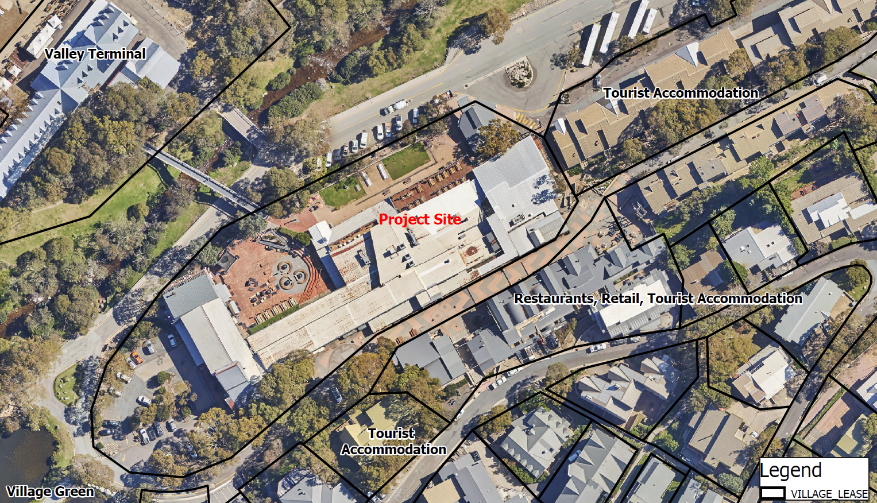
LEGEND
Temporary stockpile locations
Proposed Temporary Material Stockpile Locations
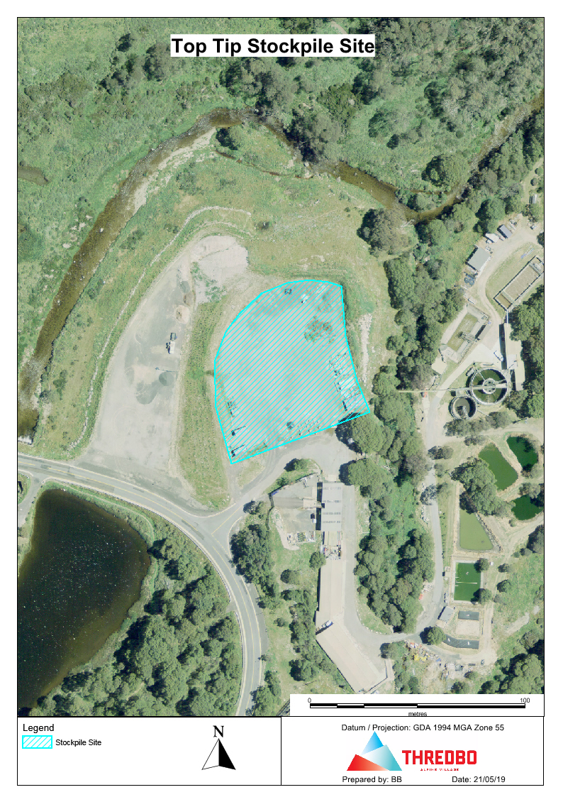
Main stockpile locations located at the Thredbo Waste Transfer Station
- Risk Matrix
Likelihood and consequence is defined as follows:
- Likelihood: the chance that something might happen; and
- Consequence: the outcome of an event which may have the potential to change the existing environmental values.

Likelihood | Consequence
 | Extreme  (5) | Major  (4) | Moderate  (3) | Minor  (2) | Insignificant  (1)
Almost certain (5) | Extreme (25) | Extreme (20) | Extreme (15) | High (10) | Moderate (5)
Likely  (4) | Extreme (20) | Extreme (16) | High (12) | Moderate (8) | Low (4)
Possible  (3) | Extreme (15) | High (12) | Moderate (9) | Moderate (6) | Low (3)
Unlikely  (2) | High (10) | Moderate (8) | Moderate (6) | Low (4) | Low (2)
Rare  (1) | Moderate (5) | Low (4) | Low (3) | Low (2) | Very low (1)

Likelihood Rating |  | Definitions
Rare | 1 | Unlikely to occur during a lifetime or very unlikely to occur
Unlikely | 2 | Could occur but considered unlikely
Possible | 3 | Might occur at some time
Likely | 4 | Will probably occur
Almost certain | 5 | Is expected to occur in most circumstances

Consequence Rating |  | Definitions
Insignificant | 1 | Very low environmental impact confined to a small area within the Project area. Prompt (typically within a shift) clean-up.
Minor | 2 | Low environmental impact confined within the Project area. Short-term (typically within a week) clean-up.
Moderate | 3 | Reversible offsite environmental impact, requiring short-term clean-up (weeks). On-site medium term (weeks) clean-up.
Major | 4 | Major, offsite, environmental impact requiring medium-term clean-up (months). On-site impact requiring significant clean-up effort (months).
Extreme | 5 | Prolonged or severe, offsite or regional environmental impact requiring long-term clean-up (years) with irreversible residual damage. Extensive, Project area impact requiring long-term clean-up and recovery (years).

- Environmental Schedules

THREDBO ENVIRONMENTAL SERVICES
SEMP WEEKLY INSPECTION REPORT

Sheet _____of_____

Project: _____________________________________________ Inspection Date: __________________

Inspected by: _______________________________

Weather: Morning Afternoon
Clear/Overcast/ Fine/Rain/Snow Clear/Overcast/Fine/Rain/Snow

Operation | Condition | Plant/Labour |  | Comments
Silt Fence
Hay Bale retention ponds

Hay Bale sediment protection
Stormwater Pit protection

Cyclone Fence
(including gates)
Para-web Fence

Site Signage

Paint Washout facility

Vehicle Wash-down

Waste Skips

Tree Protection

Verbal Discussion with Contractor: |  |  | Verbal discussion with others:
Materials Received / Required: |  |  | Site Instructions Issued:
Inspectors Report / Summary: |  |  | Action required:
Signature: ________________________________________ Date: __________________

THREDBO ENVIRONMENTAL SERVICES
Record of complaint

Sheet _____of_____

Project: _____________________________________________ Date / Time: __________________

Received by: _________________________________________ Reference Number: ____________

Complainant details: | Witness details:
Nature of complaint: …………………………………………………………………………………………………………………………………………………………………………………………………………………………………………………………………………………………………………………………………………………………………………………………………………………………………………………………………………………………………………………………………………………………………………………………………………………………………………………………………………………………………………………………………………………………………………………………………………………………………………………………………………………………………………………………………………………………………………………………………………………………………………………………………………………………………………………………………………………………………………………………………………………………………………………………………………………………………………….. Complainant sign:

Action taken: ……………………………………………………………………………………………………………………………………………………………………………………………………………………………………………………………………………………………………………………………………………………………………………………………………………………………………………………………………………………………………………………………………………………………………………………………………………………………………………………………………………………………………………………………………………………………………………………………………………………………………………………………………………………………………………………………………………………………………………………………………………………………………………………………………………………………………………………………………………………………………………………………………………………………………………………………………………………………………………………………………………………………………………………………………

Replace page with Environmental Incident Reporting Form

